Lab 11. Create a Custom Connector

**Author:** Serge Luca aka “Doctor Flow”

**Prerequisites**: creating and calling a custom connector requires a Premium connector.

Tasks:

1. Before starting this lab, make sure your API key has been generated. You can reuse the key from the previous lab.
2. Go to the **Connector** menu and select **Custom Connectors**:

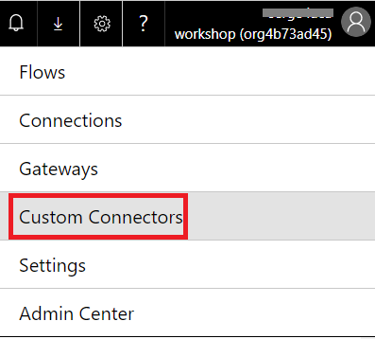

1. Click on **Create custom connector**:

newconnect

1. Select **Create from blank.**
2. Name the connector “Demo Weather” and click Continue

[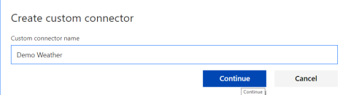](https://sergeluca.files.wordpress.com/2018/08/democustomconn2.png)

1. Click **Continue** and in the next window, provide the host (**api.weatherstack.com**) and a short description of what your connector does and also select http instead of https:

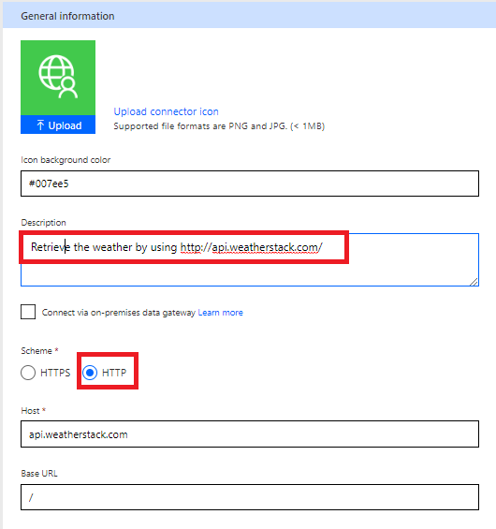

1. Click **Security** to move to the next screen.
2. The authentication type should be **API key**.
3. Since we want the Key parameter to be provided in the query string, create an API key with **key**as Parameter label and Parameter name; switch the parameter location to Query as illustrated in the following picture:

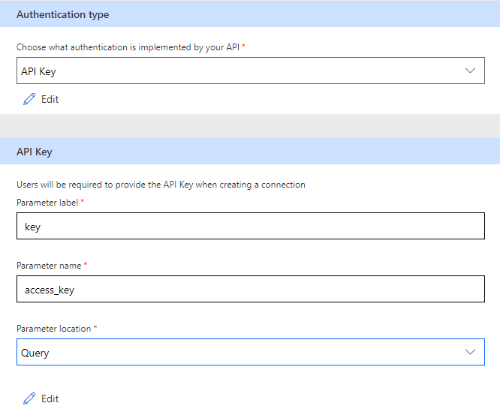

1. Click **Definition**:

[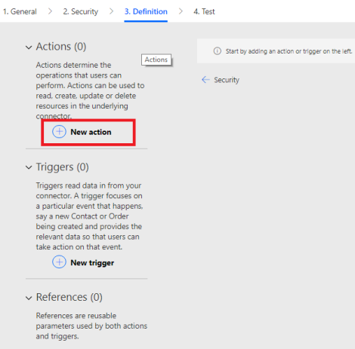](https://sergeluca.files.wordpress.com/2018/08/definition.png)

1. Click on **New action**:
2. Define the Action as follow:

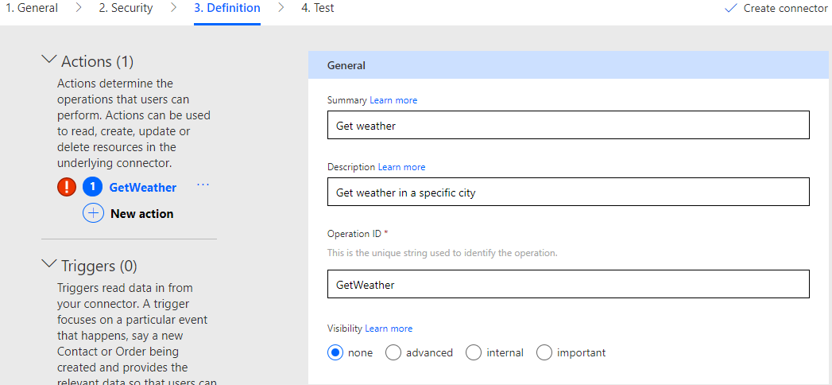

1. In a new browser tab, type a weather request to make sure it works fine and also to generate sample data that we will reuse in our connector definition (don’t forget to pass your key as a parameter, as well as the city):

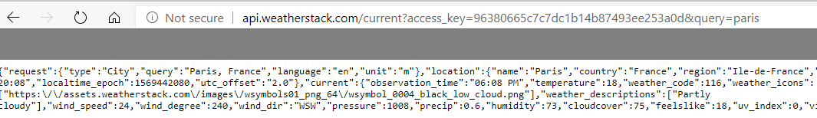

1. Keep this tab open and go back to the connector definition.
2. Down below in **Request**, click **Import from sample**

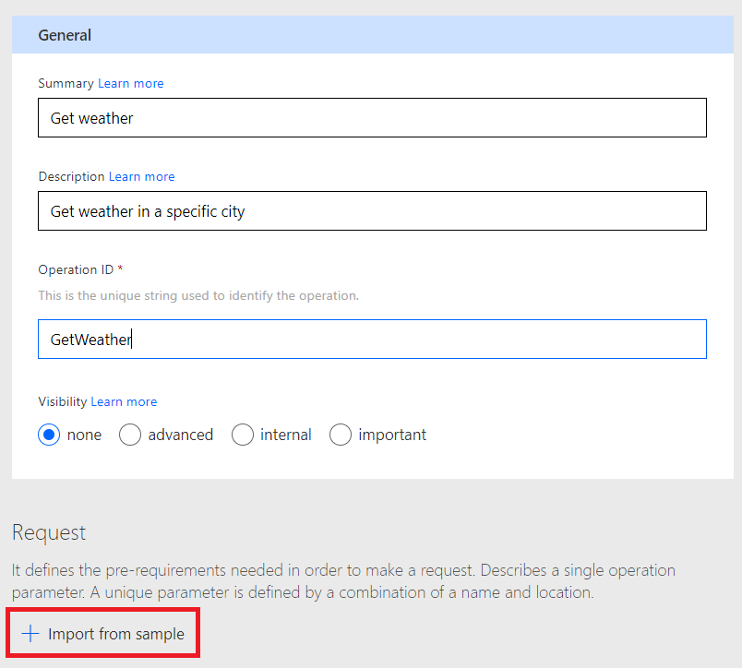

1. Pass your query string, set the verb to **Get** and click i**mport**

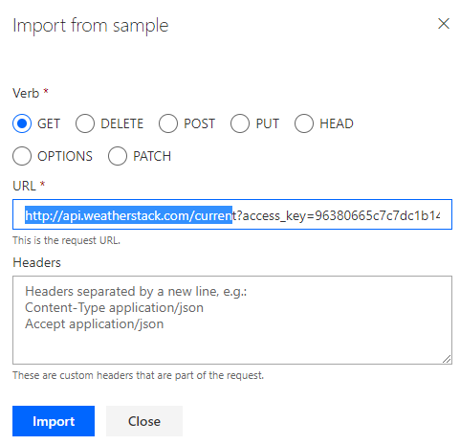

1. 2 parameters will be visible in a Query: **access_key**, **query.**
2. The access_key will be registered in the connector, in such way that there is no need to pass the key for each query; therefore we can delete it:

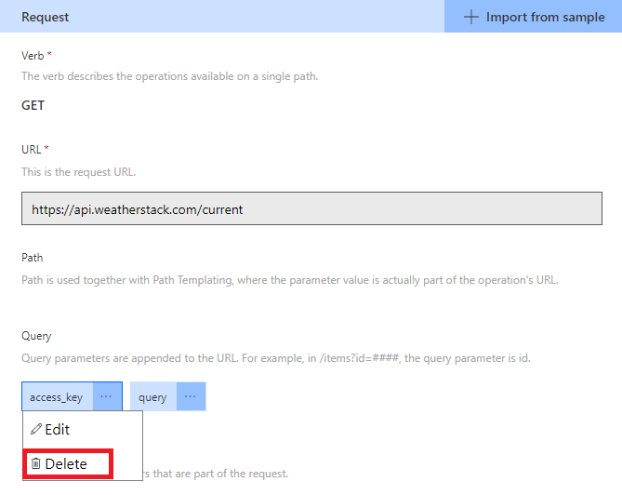

1. Edit the **query** parameter and fill in the **Description** as “Fill in the City Name”, **Summary** as “city name” and make the fields required:

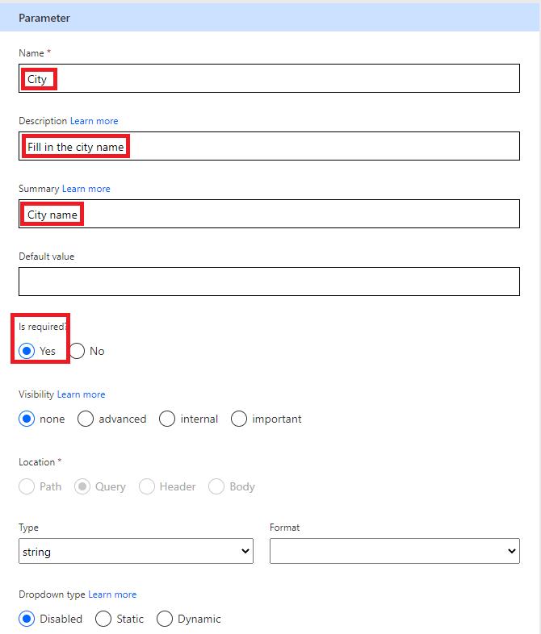

1. Click on **Back**, scroll to **Response**, click on **default** to import another sample; the scroll bar is in the middle of the screen as illustrated in the picture:

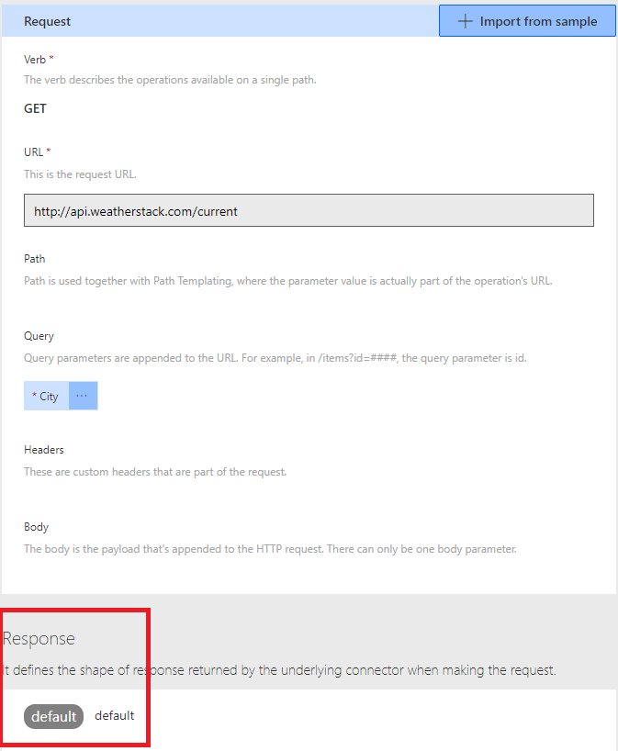

1. In the next window, click on **Import from sample**:

[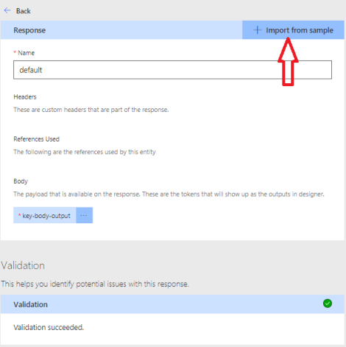](https://sergeluca.files.wordpress.com/2018/08/responseimport.png)

1. …and in the next window, paste the JSON result grabbed from the browser:

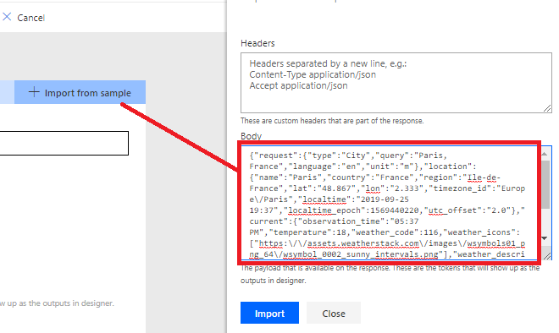

1. Click **Import**.
2. Click **Create Connector**

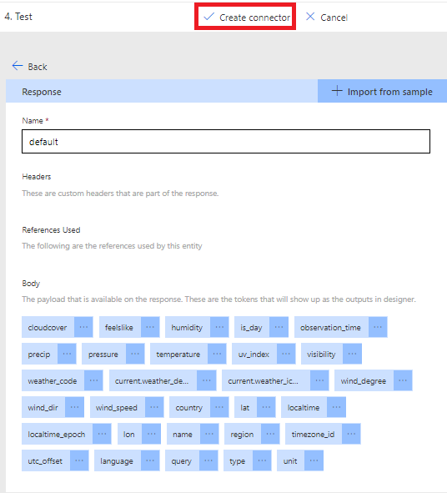

1. You can now test the connector (click Test):

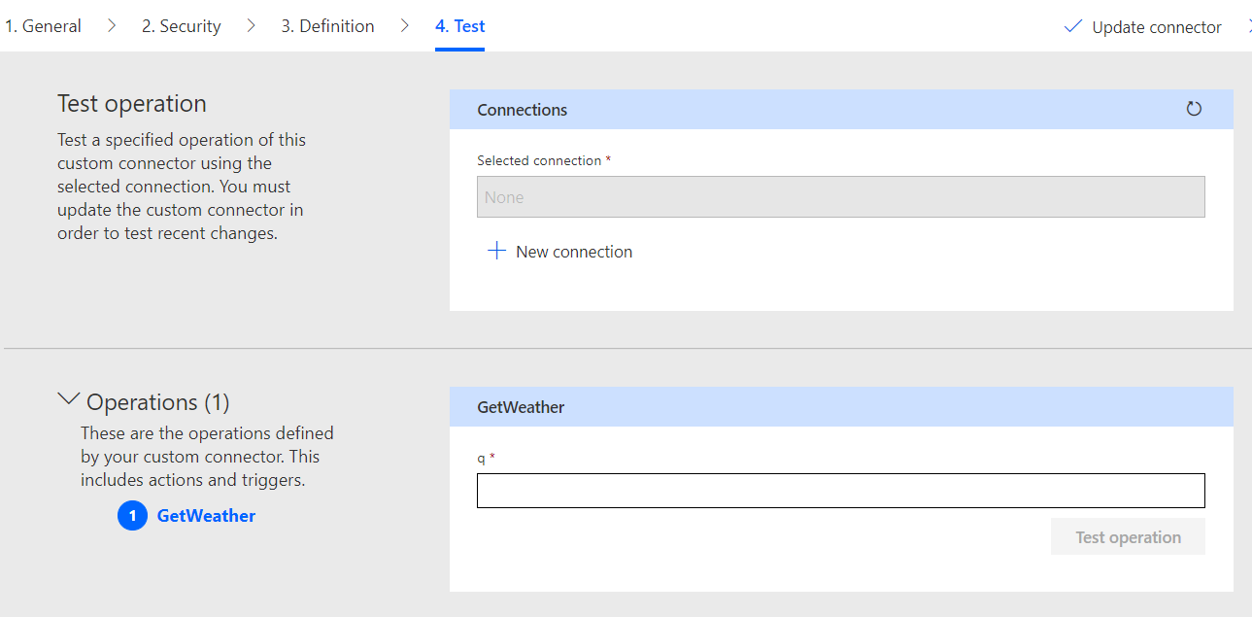

1. However, you need to create a New connection; click on **New connection,** provide your key, and click again on Create connection:

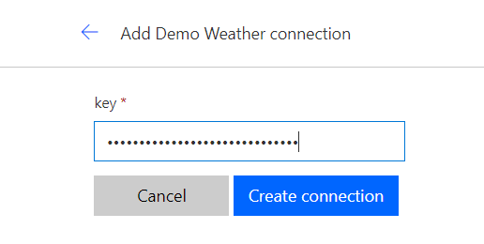

1. You will be redirected to the previous page, where you can click the refresh icon in order to display the new connection:

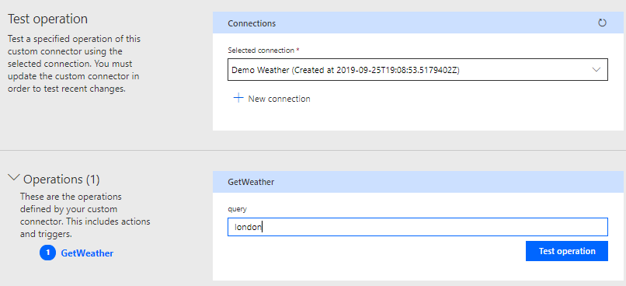

1. Provide a city name, like London, click **Test Operation** and you should get the corresponding weather

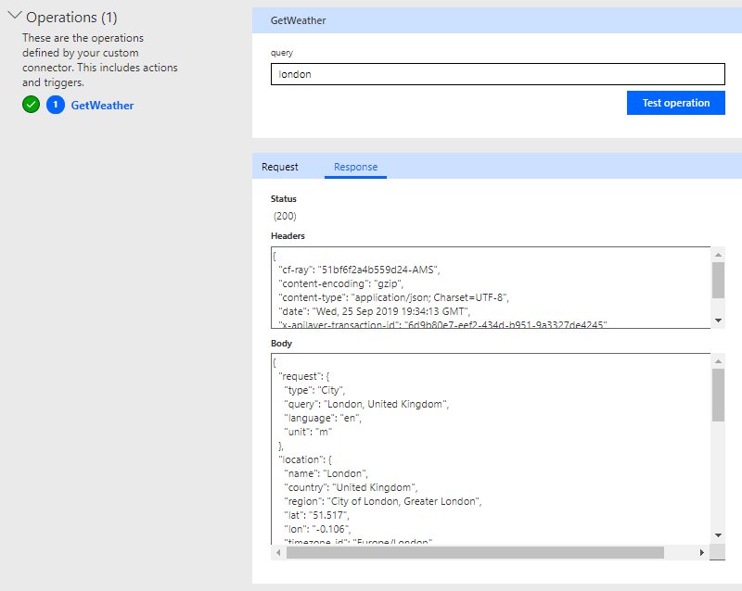

1. Click close, and you will notice that your connector has been created:

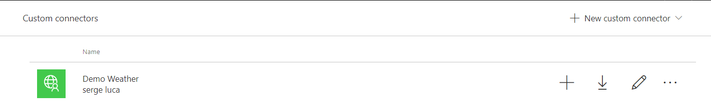

1. You can now create an instant Flow from blank to use this custom connector

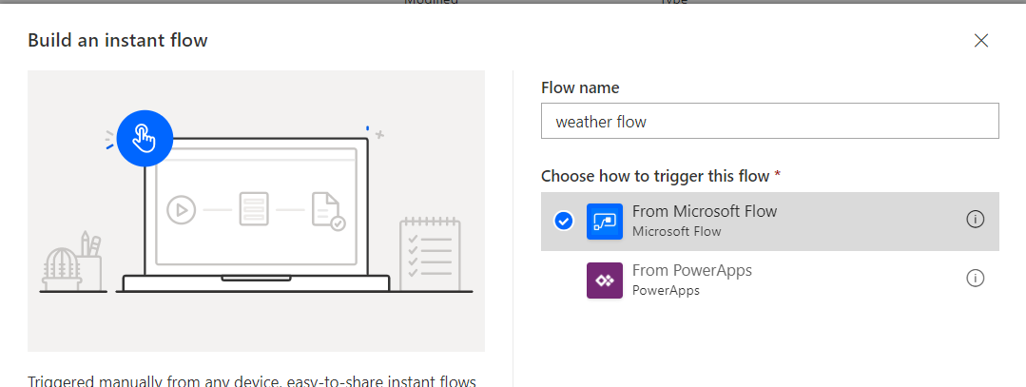

1. Add an “action” from the Custom category; you should find you Demo Weather custom connector:

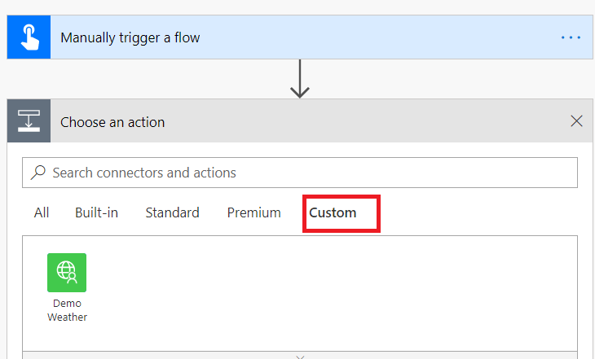

1. Select the **Get Weather** action

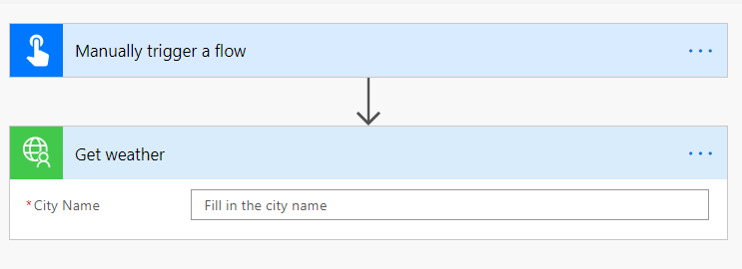

1. Provide London as the city name and save your Flow:

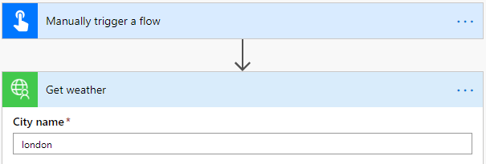

1. Run the Flow and check the output of “Get Weather”:

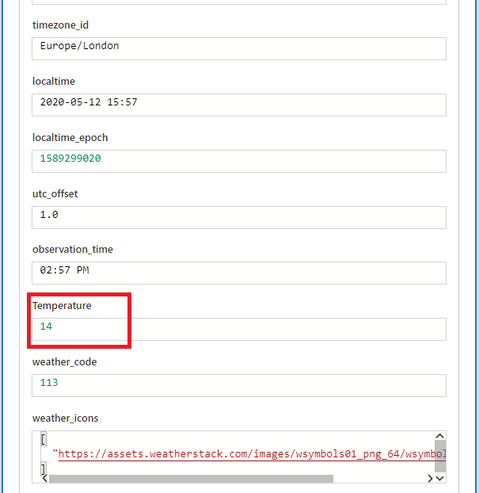

Add a **Compose** and store the **temp**erature value:

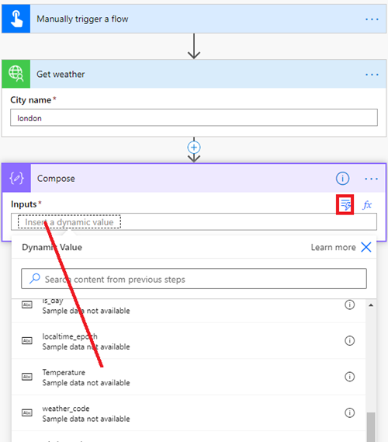

1. As you can see, using a custom connector is more convenient than using the HTTP action. However we can make it even easier to use for power users: for instance, instead of having to use the name **Temperature,** we can modify the custom connector definition with **temperature in Celcius**.
2. Go back to your custom connector definition and click the Edit icon:

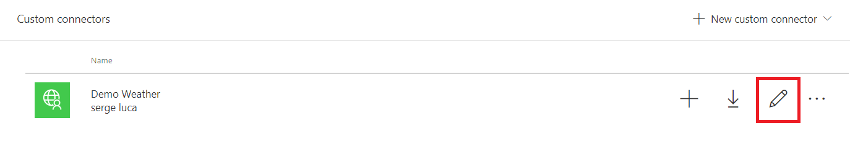

1. Go to Definition and click Default in Response:

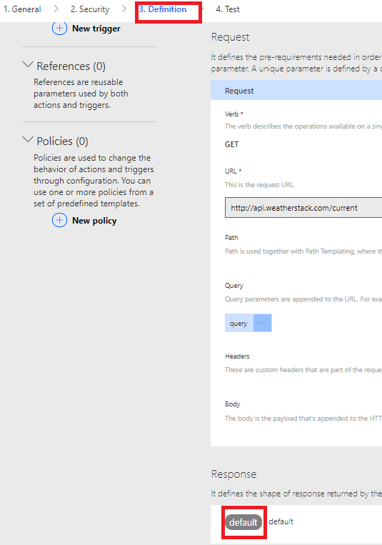

1. Edit temperature:

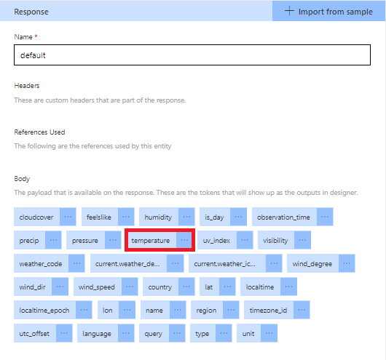

1. Change the Title and the description:

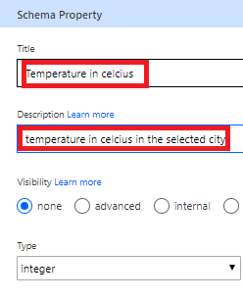

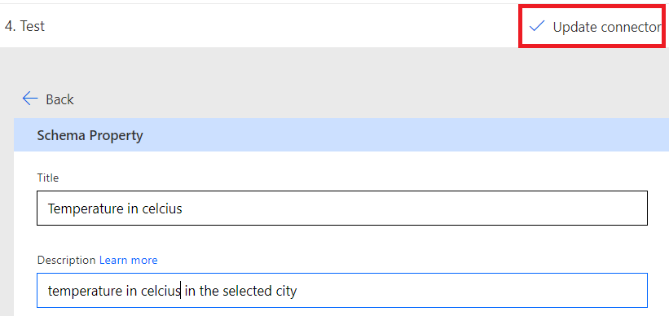

1. Update your Flow; you should see the new property label:

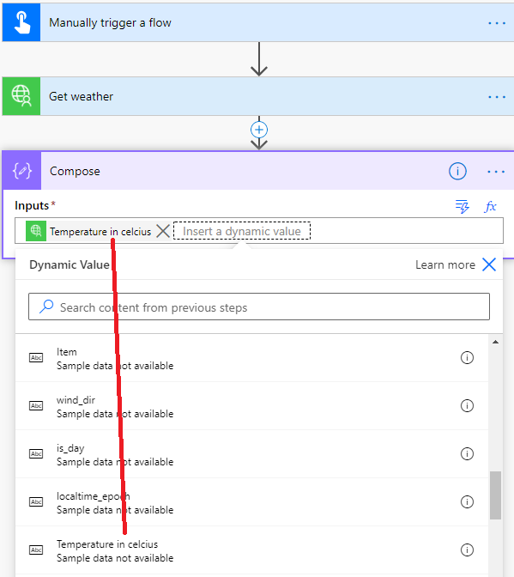

**We need your feedback**

Do you want to report an issue or to suggest something? We need your feedback: <https://github.com/Power-Automate-in-a-day/Training-by-the-community/issues>